Quantifying Organizational Efficiency Gains from AI-Driven
Treatment Decision Tools: An Agent-Based Modeling and
Strategic Management Perspective

- Introduction
The rapid integration of artificial intelligence (AI) into healthcare has generated high expectations regarding improvements in diagnostic accuracy, treatment personalization, and clinical decision-making. AI-driven treatment decision tools are now deployed across domains such as radiology, clinical triage, oncology, and digital therapeutics. However, despite strong algorithmic and task-level performance, AI adoption does not automatically translate into improved organizational efficiency. Many healthcare organizations continue to face prolonged patient waiting times, clinician workload overload, congestion, and rising operational costs even as AI-enabled solutions proliferate.
The disconnect between the promise and reality of AI reflects a major shortcoming in current AI evaluation methods. Existing assessments focus on clinical accuracy, predictive performance, or user satisfaction, often treating healthcare organizations as passive environments in which technologies operate. Such perspectives overlook the fundamentally organizational nature of healthcare delivery, where outcomes emerge from interactions among patients, clinicians, resources, workflows, and decision-making processes over time. Therefore, an improvement to the task level may not necessarily lead to an increase in system-wide efficiency and may perhaps introduce new types of coordination failure.
From a value-based healthcare perspective, the objective of healthcare delivery is the value created for patients—defined as outcomes achieved relative to the total cost of care across the full treatment cycle. Yet organizational value remains difficult to measure in practice due to fragmented workflows, siloed performance metrics, and limited analytical tools capable of capturing system-level dynamics. This challenge is particularly salient in the context of AI adoption, where efficiency gains are frequently assumed rather than empirically demonstrated.
Healthcare delivery operates as a complex adaptive system in which local decision delays propagate through feedback loops, amplifying congestion, increasing length of stay, and degrading overall performance. These characteristic limits the applicability of linear or static evaluation approaches and motivates the use of modeling frameworks capable of capturing emergent organizational behavior.
In response, this study conceptualizes AI-driven treatment decision tools not merely as clinical technologies, but as organizational process innovations that reshape decision timing, coordination mechanisms, and variability within healthcare systems. An agent-based modeling (ABM) approach is adopted to explicitly represent heterogeneous actors and their interactions under capacity constraints, enabling analysis of how local decision-support interventions give rise to system-level outcomes such as efficiency, stability, and value creation.
The primary objective of this research is to quantify organizational efficiency gains associated with AI-driven treatment decision tools, moving beyond accuracy-focused evaluations toward system-level performance assessment. Specifically, the study addresses the following research questions:
- How do AI-assisted treatment decision tools influence organizational efficiency metrics such as length of stay, throughput, and decision latency?
- To what extent do AI-driven decision tools reduce artificial variability and improve system stability under identical demand and capacity conditions?
- How can organizational value, understood as outcomes achieved per unit of organizational effort, be operationalized and compared between traditional and AI-assisted decision regimes?
To answer these questions, the study develops an agent-based simulation framework that models patient flows, clinician decision-making, and AI-supported interventions within a healthcare organization. By integrating organizational efficiency metrics with value-based management principles, the proposed framework offers a systematic ex ante method for evaluating the strategic impact of AI-driven treatment decision tools and provides actionable insights for healthcare managers and policymakers seeking sustainable efficiency improvements.

Background and Motivation
2.1 Pressure on Healthcare Organizations
Healthcare organizations worldwide operate under increasing structural pressure driven by rising patient demand, constrained resources, and growing workforce challenges. Demographic changes, the prevalence of chronic diseases, and heightened expectations for timely, high-quality care have collectively intensified demand for healthcare services. At the same time, hospitals and care providers face persistent capacity limitations related to staffing shortages, bed availability, and financial constraints. These pressures are further compounded by widespread clinician burnout, which negatively affects decision quality, productivity, and staff retention.
Within this context, healthcare organizations face ongoing challenges in improving efficiency without compromising care quality. Value-based healthcare perspectives question the inevitability of this trade-off by emphasizing that outcomes and efficiency can be jointly improved when waste, delays, and unnecessary variability are systematically reduced.
Recent analyses of healthcare innovation indicate that many inefficiencies stem not from insufficient clinical expertise or lack of advanced technologies, but from organizational factors such as delayed decision-making, poor coordination, and misaligned workflows. Under these conditions, the ability to deliver high-value care increasingly depends on how effectively healthcare organizations manage timing, coordination, and resource allocation rather than on incremental increases in capacity alone.
2.2 AI as Organizational and Strategic Innovation
Artificial intelligence has emerged as a prominent response to the operational and cognitive pressures faced by healthcare systems. AI-driven treatment decision tools are increasingly deployed to support clinicians in tasks such as triage, diagnosis, treatment planning, and patient monitoring. While these technologies are often assessed in terms of predictive accuracy or technical performance, their organizational implications are equally important.
From an organizational perspective, AI reshapes how decisions are made, coordinated, and executed within healthcare workflows. By accelerating decision-making, standardizing recommendations, and integrating heterogeneous data sources, AI tools influence task distribution, communication patterns, and temporal dynamics across care processes. These changes affect patient flow, redistribute clinician workload, and modify prioritization and escalation mechanisms, thereby shaping system-wide performance.
From a strategic management viewpoint, AI-driven treatment decision tools represent process innovations whose value lies not in replacing human expertise, but in augmenting organizational decision processes in ways that reduce delays, improve coordination, and enhance consistency under uncertainty. Their impact on organizational efficiency therefore depends on how effectively they reshape decision timing and workflow interactions rather than on technical capabilities alone.

2.3 Research Gap: Organizational-Level Efficiency
Despite the rapid diffusion of AI-driven treatment decision tools, existing research has predominantly focused on micro-level outcomes such as algorithmic accuracy, diagnostic performance, and user satisfaction. Systematic reviews of clinical decision support systems show that evaluations largely emphasize usability, acceptance, and perceived usefulness, with limited attention to organizational performance over time.
While studies on adoption and user perceptions provide valuable insights into trust and behavioral intentions, they do not adequately address whether AI systems generate measurable efficiency gains at the organizational level. Specifically, the literature lacks dynamic, system-wide analysis of indicators such as patient flow dynamics, variability in length of stay, capacity utilization, and delay-induced costs. As a result, claims regarding efficiency improvements associated with AI adoption are often inferred rather than empirically demonstrated.
This gap is particularly consequential because many organizational inefficiencies arise from dynamic interactions and feedback mechanisms that cannot be captured through static or user-centered evaluation methods. Without analytical approaches capable of modeling how AI-driven decision support influences coordination, timing, and variability across healthcare systems, decision-makers lack robust evidence to guide strategic adoption and governance of AI technologies.
Addressing this gap requires an evaluation approach that moves beyond task-level performance and individual perceptions to examine how AI-driven treatment decision tools reshape organizational dynamics and value creation. This study responds to this need by adopting a system-level, simulation-based perspective focused on organizational efficiency, stability, and value-based outcomes.

3. Related Work
3.1 AI-Driven Treatment Decision Tools
Recent years have witnessed a rapid expansion of AI-driven treatment decision tools across a wide range of healthcare domains. Applications include medical imaging interpretation in radiology, symptom assessment and triage systems, clinical monitoring platforms, and digital therapeutics designed to support personalized treatment and early intervention. These tools are primarily designed to assist clinicians by processing large volumes of data, identifying patterns, and generating recommendations that would otherwise be time-consuming or cognitively demanding for human decision-makers.
Existing literature highlights the potential of AI systems to improve diagnostic accuracy, accelerate clinical workflows, and support earlier and more informed treatment decisions. Large-scale reviews emphasize performance gains in specific tasks such as image analysis, risk prediction, and early warning systems, often demonstrating parity or superiority relative to human experts under controlled conditions. More recent surveys further document the breadth of AI applications across healthcare delivery, noting growing interest in AI-enabled monitoring and decision support as responses to workforce shortages and increasing demand.
However, while these studies provide valuable evidence of technical and clinical feasibility, their evaluations are largely confined to task-level performance or clinical outcomes. Organizational consequences—such as changes in patient flow, workload distribution, or system stability—are typically discussed qualitatively or assumed implicitly. As a result, the extent to which AI-driven treatment decision tools deliver measurable organizational efficiency gains remains insufficiently explored.
3.2 Cost, Quality, and Efficiency in Healthcare
A substantial body of healthcare management literature has examined the relationship between cost, quality, and efficiency, challenging the notion that improvements in one dimension necessarily compromise the others. Seminal work in managed care argues that inefficiencies in healthcare systems are often driven not by inadequate clinical quality or insufficient resources, but by unmanaged variability in demand, decision-making, and coordination. This perspective distinguishes between natural variability inherent to patient populations and artificial variability introduced by organizational practices such as delayed decisions, poor scheduling, and fragmented workflows.
From this viewpoint, significant efficiency gains can be achieved by reducing artificial variability before reaching a threshold at which quality deterioration becomes unavoidable. Importantly, this literature critiques traditional cost-effectiveness analyses for focusing narrowly on clinical interventions while neglecting the role of management decisions and system-level interactions. Efficiency, therefore, emerges as an organizational property shaped by timing, coordination, and process design rather than by isolated cost reductions.
Value-based healthcare frameworks further reinforce this perspective by defining success in terms of outcomes achieved relative to the total cost of care over the full treatment cycle. By emphasizing longitudinal measurement and system-wide outcomes, these approaches highlight the limitations of fragmented performance metrics and underscore the need for integrated evaluation methods capable of capturing both efficiency and quality simultaneously.
3.3 Simulation and Systems Modeling in Healthcare
Recognizing the limitations of static and linear evaluation methods, researchers have increasingly turned to systems modeling approaches to study healthcare organizations. Complexity science characterizes healthcare systems as complex adaptive systems in which outcomes arise from non-linear interactions among heterogeneous actors operating under uncertainty and constraints. In such systems, local improvements do not necessarily translate into global performance gains, and well-intentioned interventions may produce counterintuitive or unintended consequences.
Systems dynamics research emphasizes the importance of feedback loops, time delays, and accumulation effects in shaping organizational behavior over time. From this perspective, traditional empirical approaches that rely on point estimates or short-term observations are insufficient to capture long-term efficiency, stability, and resilience. Simulation-based methods offer a complementary approach by enabling experimentation in a virtual environment, allowing decision-makers to explore alternative policies and interventions without disrupting real-world operations.
These insights have motivated calls for dynamic modeling frameworks that can represent organizational complexity explicitly and support policy exploration rather than prediction. Such approaches are particularly relevant for evaluating AI-driven interventions, whose effects may propagate indirectly through changes in decision timing, coordination, and workload.
3.4 Agent-Based Modeling in Healthcare
Among simulation techniques, agent-based modeling has emerged as a particularly suitable approach for studying healthcare systems characterized by heterogeneity, adaptation, and decentralized decision-making. ABM represents systems as collections of autonomous agents—such as patients, clinicians, and organizations—whose interactions generate emergent system-level behavior. This bottom-up perspective aligns naturally with the complex adaptive nature of healthcare delivery.
Prior ABM studies in healthcare have demonstrated the utility of this approach for analyzing patient flow, capacity constraints, policy interventions, and resource allocation. Large-scale agent-based frameworks have been developed to examine system behavior under varying demand scenarios, enabling evaluation of congestion, length of stay, and transfer dynamics. Methodological guides further emphasize best practices for agent design, validation, and interpretation, highlighting the importance of transparency, pattern-oriented validation, and scenario-based analysis.
Despite these advances, relatively few ABM studies have been applied to the evaluation of AI-driven treatment decision tools from an organizational efficiency perspective. Existing models often focus on epidemiological dynamics or capacity planning without explicitly modeling decision support technologies or their effects on workflow timing and variability. This gap motivates the present study’s use of ABM to examine how AI-assisted decision-making reshapes organizational performance and value creation within healthcare systems. Unlike prior ABM studies that focus on capacity or epidemiological dynamics, the present model explicitly represents AI-driven reductions in decision latency and variability as organizational mechanisms

4. Conceptual Framework
The conceptual framework of this study integrates insights from complexity science, healthcare operations management, and value-based healthcare to explain how AI-driven treatment decision tools influence organizational performance. Healthcare delivery is conceptualized as a complex adaptive system, in which outcomes are not direct outputs of individual technologies or decisions, but emergent properties arising from interactions among heterogeneous actors operating under capacity and timing constraints. Within such systems, local decisions can propagate through feedback loops and time delays, amplifying or dampening organizational inefficiencies over time.
Central to the framework is the distinction between natural and artificial variability in healthcare operations. Natural variability arises from inherent differences in patient conditions and demand patterns, whereas artificial variability is introduced by organizational practices such as delayed decision-making, inconsistent prioritization, and poor coordination. Prior research has shown that artificial variability is a primary source of congestion, inefficiency, and instability in healthcare systems. In this framework, AI-driven treatment decision tools are conceptualized as interventions that primarily act on artificial variability by accelerating decision processes, improving consistency, and enhancing temporal coordination across care pathways.
Organizational performance emerges through feedback mechanisms generated by interactions among patients, clinicians, and resources. Delays in treatment decisions can increase patient severity, leading to longer lengths of stay and higher resource utilization, which in turn exacerbate congestion and further delays. Conversely, timely and consistent decision-making dampens these feedback loops, stabilizing patient flow and reducing cumulative inefficiencies. AI-driven decision support influences organizational outcomes by modifying the strength and direction of these feedback mechanisms rather than by increasing capacity or reducing demand.
To translate these dynamic processes into measurable outcomes, the framework links agent interactions and feedback loops to a set of organizational key performance indicators (KPIs). These KPIs capture multiple dimensions of performance, including efficiency (e.g., length of stay, throughput), stability (e.g., variability and congestion), and quality-preserving outcomes (e.g., deterioration and escalation rates). Emphasis is placed on variability- and distribution-based measures, reflecting the insight that system stability and resilience are critical determinants of sustained organizational performance.
Finally, the framework situates these KPIs within a value-based management perspective. Organizational value is defined as outcomes achieved relative to the organizational effort required to deliver care across the full treatment cycle. From this viewpoint, efficiency improvements contribute to value only when they preserve patient outcomes and system stability. By connecting agent-level behavior to feedback dynamics, organizational KPIs, and value-based outcomes, the proposed framework provides a coherent structure for evaluating AI-driven treatment decision tools as organizational process innovations, rather than isolated technological artifacts.

5. Methodology
This​‍​‌‍​‍‌ research uses an agent-based model (ABM) to analyze the organizational impact of AI-based treatment decision tools. ABM is very compatible with healthcare systems since these reveal the main features of complex adaptive systems such as diverse agents, nonlinear interactions, feedback loops, and time delays. In such systems, the determinants of the organizational outcomes, e.g. the achievement of factors such as efficiency, congestion, and stability, are the local decision-making processes rather than the centralized control systems.
ABM allows the modeling of individual actors in healthcare such as patients and clinicians whose interaction under capacity constraints lead to system level performance, unlike other linear or aggregate modeling approaches. Having this kind of detail at the level of individuals is necessary for studying how AI decision support affects the timing, coordination, and variability of decisions throughout care processes. ABM is a perfect tool for capturing adaptation, bounded rationality, and interaction effects, thus, micro-level behavior can be linked without difficulty to macro-level organizational outcomes.
In terms of strategic management, this micro–macro connection is vital for determining the extent to which digital decision-support tools are capable of reducing costs, eliminating process bottlenecks, and enhancing mechanisms of value creation along the organizational value ​‍​‌‍​‍‌chain.
5.1 Scenario-Based Evaluation
The​‍​‌‍​‍‌ model serves to compare scenarios rather than to optimize or predict. Under similar demand and capacity conditions, two main decision regimes are analyzed: a conventional clinician-only decision method and an AI-supported decision process. Such a comparative setup enables the isolation of organizational impacts of AI decision support without mixing changes in staffing levels, patient demand, or clinical accuracy.
Scenario-based simulation also facilitates strategic learning by permitting controlled experiments in a virtual setting. This method is in line with systems thinking views that highlight the investigation of the effects of policies over time, especially in situations where real-world experimentation would be expensive, dangerous, or ​‍​‌‍​‍‌impossible.
5.2 Patient Agents
Patient​‍​‌‍​‍‌​‍​‌‍​‍‌ agents form the largest demand group of the system. A patient's clinical condition describes the patient's health status at a given time, and the condition can change because of different treatment decisions running through the clinical treatment process. The decrease in patient's health status due to wait times is referred to as deterioration. The patient's initial condition (first severity), tolerance to waiting, and the degree of worsening of the patient's condition when the patient's waiting time is long are the main patient characteristics that determine the effects of these delays on the patient's condition and are the key influences on the patient's deterioration level.
During the entire course of care, a patient goes through a series of stages such as waiting for the clinical decision, getting treated, and finally getting discharged. The longer the patient's clinical decision is delayed the greater is the chance of the patient's condition being aggravated; this leads to longer stays and increased use of hospital facilities. The damage that the patient experiences due to this waiting time does not show itself at first instance; it is rather that the harm accumulates over time as the waiting time increases.
This patient modeling technique basically enables the simulation to demonstrate how the patient's condition deteriorates and the resulting increase in hospital stay and resource utilization caused by waiting for the clinical decision combine to negatively affect the hospital's overall performance, increase congestion, length of stay, and pressure on limited ​‍​‌‍​‍‌​‍​‌‍​‍‌resources.

5.3 Clinician Agents
Clinician​‍​‌‍​‍‌​‍​‌‍​‍‌ agents are the main bottleneck of decisions in the whole healthcare system. They have the primary responsibility of identifying patients' needs and making clinical decisions, which means that their performance is impacted by workload and time pressure. In line with this, clinicians take more time for decisions when the system is highly congested.
Decision time is thus not a constant. Rather, it varies continuously depending on how busy clinicians are and the number of patients waiting. Hence, the model can realistically represent the working conditions by showing that delays worsen as workloads increase.
In each of the traditional and AI-assisted scenarios, clinicians still have the final say on clinical decisions. The availability of AI support indicates that it can shorten the time for the clinicians' decision-making and provide consistency, therefore, minimizing delays while keeping human control. Thus, the AI is here seen as a tool that helps in clinical decision-making without displacing clinicians.
The model, by linking decision time to workload, literally depicts how human factors affect the performance of the system and how decision-support technologies can lessen congestion and lead to better patient ​‍​‌‍​‍‌​‍​‌‍​‍‌flow.
5.4 AI Decision Support Modeling
AI-based​‍​‌‍​‍‌​‍​‌‍​‍‌ decision support is depicted as a device that helps clinicians accomplish tasks rather than replacing them. With the model, AI does not make treatment decisions independently. After that, it affects how fast and consistently clinicians can make decisions.
The primary impact of AI is shortening decision time and its variation, thus, making the decision-making process more stable and predictable even at high workloads. Nevertheless, the model does not assume that AI enhances accuracy in diagnosis or clinical outcomes.
This scenario is in line with the study's main focus on the organizational aspects of medical facilities and not on their medical efficiency. The simulation ignores changes in diagnostic accuracy so as to single out the contributions of AI to coordination, timing, and workload management. Thus, the model underlines the fact that AI can help via clinical workflow support, system efficiency gains, etc., rather than by simply beating clinicians in clinical judgment.
5.5 Organizational KPIs and Strategic Interpretation
The organizational performance is assessed with the help of a set of key performance indicators (KPIs) specially designed to capture efficiency, stability, and overall system behavior. Some major efficiency metrics comprise average length of stay, throughput, and decision latency. The combination of these three indicators illustrates how fast patients are helped and how, to what extent, the scarce organizational resources are utilized.
The value-chain analysis unveils that the KPIs and their corresponding changes facilitate the recognition of the primary operating bottlenecks, especially those in clinical decision-making, as well as the discovery of the inefficiencies of secondary activities, such as human resource coordination and capacity management. The decrease in decision latency means that there has been a performance gain in the clinic, whereas the drop in the length of stay is a sign of an effective smoother downstream operation. The connection of the main KPIs with the main managerial frameworks as discussed in the course can be seen in Table 1.
System stability is also gauged by variability-related measures such as variability in length of stay and fluctuations in resource utilization. Such indicators are essential because if variation in the system is high, this usually implies that it is crowded, staff is overloaded, and under such conditions, operational reliability is reduced, even if average performances seem to be satisfactory.
All the KPIs are combined to form a composite organizational value index that is based on value-based healthcare principles and is meant to reflect organizational performance. Within the value-based organizational framework, organizational value is the output over the input in delivering healthcare services. Effort is approximated by time in the system, capacity utilization, and congestion levels. The incentive structure limits patient waiting, fluctuation, and deterioration while at the same time it rewards patient flow in a timely manner and stable system behavior.
The composite score is then used as a decision-support tool for comparative purposes to identify alternative AI adoption scenarios under identical capacity constraints. In terms of business strategy at the corporate level, it is the fact that throughput can be increased without adding more resources that signify operational efficiency improvements and, thus, a cost-leadership orientation. Even so, decreases in irregularities and congestion indicate that the organization's response to demand pressure is more resilient. Therefore, it has a stronger competitive position in the uncertain and resource-light market. As demonstrated by Table 1, these repercussions can be straightforwardly related to value-chain Perspective, business-level strategy, and competitive ​‍​‌‍​‍‌​‍​‌‍​‍‌dynamics (Organizational Resilience).

Table 1: Mapping of Organizational KPIs to Managerial Frameworks
KPI | Value Chain Perspective | Business-Level Strategy | Five Forces / Organizational Resilience
Decision Latency | Support activities (HR coordination, clinical decision processes); reduction of decision-making bottlenecks | Cost leadership through time-based efficiency | Reduced internal inefficiencies, improved responsiveness under competitive pressure
Length of Stay (LOS) | Primary operations; efficiency of service delivery | Lower cost per patient and improved operational efficiency | More predictable service levels, improved bargaining position with patients
Throughput | Primary operations; system output under fixed capacity | Cost leadership via higher output without additional resources | Increased competitiveness in high-demand environments
LOS Variability | Stability of operational processes | Quality differentiation through predictability and reliability | Greater resilience to demand fluctuations and operational stress
Utilization Variance | Infrastructure and resource management | Cost control through reduced capacity waste | Lower operational risk and improved stability under rivalry
Composite Value Index | Integrated view across the entire value chain | Balanced evaluation of efficiency and quality | Strategic decision support under uncertainty

6. Scenario Design and Experimental Setup
6.1 Demand and Capacity Control
To​‍​‌‍​‍‌​‍​‌‍​‍‌ ensure a fair comparison across different decision regimes, the simulation experiments keep patient demand and organizational capacity unchanged throughout the study. Patients arriving at the hospital matching the same stochastic arrival process for all cases implies a fixed external demand that the hospital cannot directly control. Patients enter the system and wait for clinical decisions when they first come to the hospital.
Organizational capacity is also maintained at the same level in all scenarios, including bed availability and treatment resources. The only structural change between the scenarios is the number of clinicians and the presence or absence of AI-based decision support in the scenario. This scenario setting reflects a realistic managerial situation where new technologies are introduced to the existing infrastructure or physical resources without their immediate expansion.
By fixing demand and capacity, the simulation can focus on the effect of decision-making processes, that is decision timing, coordination, and variability, on the organizational performance. Therefore, any differences in results are due to changes in decision regimes rather than external capacity changes. This stable setting also ensures that differences in performance metrics can be attributed to changes in decision-making regimes rather than differences in demand or capacity.
6.2 Baseline Scenario: Traditional Clinical Decision-Making
In the baseline scenario, patient care is performed under a traditional decision-making regime. Four clinicians independently evaluate patients and determine their treatments without the assistance of AI. Decision times are considered stochastic variables to mirror natural variability due to factors such as cognitive load, case complexity, and working conditions.
The patients have diverse features in terms of initial clinical severity, willingness to wait, and the risk of deterioration. The longer the patients are waiting for clinical decisions, the more likely are the delays to cause deterioration, which in turn leads to worsening conditions and longer treatment durations. This feature thus represents the effect of accumulated waiting over time instead of immediate or binary clinical outcomes.
After decision-making, patients are directed towards treatment, if there are beds available. At the same time, the model captures the evolution of some key indicators such as decision latency, waiting time, length of stay, and clinical deterioration. This scenario depicts the benchmark against which the AI-assisted settings are compared.
6.3 AI-Assisted Scenario: Reduced Staffing with Decision Support
In the AI-assisted scenario, the authors keep unchanged the organizational demand as well as the patient-related characteristics. However, the clinician team is reduced from four to three clinicians. AI-based decision support is thus introduced to help all the remaining clinicians.
AI does not substitute clinical judgment, nor does it interfere with diagnostic accuracy. On the contrary, the focus of AI’s actions is limited to efficiency in decision-making. Practically, AI support is viewed as a percentage decrease in both the average and the standard deviation of the clinician's decision latency. As a matter of fact, a 10% AI intervention level means a 10% cut in both the average decision time and its variation.
The authors run this scenario for different AI effectiveness levels (e.g., 10%, 20%, 30%, and higher), thus gradually exposing the impact on the organizational performance of increasing the decision support. The importance is in deciding if, and under which situations, better decision efficiency can compensate for a lowered level of staffing.
6.4 Comparative Objective and Performance Evaluation
The main goal of the scenario comparison is to determine whether AI-assisted decision-making by three clinicians can match or have better results than the baseline setting of four clinicians under traditional conditions. The assessment of the performance is based on organizational KPIs listed earlier including length of stay, throughput, decision latency, and variability.
The​‍​‌‍​‍‌​‍​‌‍​‍‌ simulation results are first visualized with comparative plots and overall statistics to pinpoint the thresholds, trade-offs, and nonlinear effects in the performance. A big part of the analysis is dedicated to figuring out to what extent the AI-driven decision latency reduction level should be in the AI-assisted case to at least match or even outperform the baseline case. We quantitatively compare these two cases' results, and thus differences in their performance on the most important indicators and demand levels, are also discussed.
6.5 Sensitivity and Robustness Analysis
Sensitivity analyses are also carried out alongside the main scenario comparison to check how changes in results are impacted by the most influential assumptions in the model. These analyses look into changes in AI efficiency, workload impact, and limit setting for deterioration. In fact, the simulation doesn't settle on a single best configuration but rather runs various scenarios within reasonable assumptions to bring out regularities, turning points, and compromises.
Simulation serves as a knowledge-gaining instrument in policy and managerial design along these lines, so that decision-makers get a grasp of organizational performance changes under different technology adoption strategies and uncertainty. These sensitivity analyses put the spotlight on parameters rather than the managerial interpretation, which is dealt with from a policy experimentation standpoint.
6.6 Policy Experimentation Perspective
The experimental setup can still be understood from a more general policy experimentation standpoint if one takes sensitivity analysis into account. It thus takes the form of a policy experiment in which the AI-supported decision-making process is the organizational intervention whose effects are getting revealed over time as feedback and congestion dynamics play out. The attention is not only centered on the short-term gains in average performance but also stability, resilience, and system behavior under demand pressure over a longer period are considered.
The simulation indicates that, depending on the decision regime, the system exhibits different patterns of congestion and how work stress affects it. The information from the simulation experiment based on this observation can be useful for strategic planning, workforce designing, and healthcare technology governance.

7. Results
This article provides the outcomes of the agent-based simulation experiments that illustrate the comparison of the decision regime by a clinician only with the one using AI-assisted decision support. To make sure that the comparison is fair, the demand process, bed capacity, treatment capacity, and patient heterogeneity assumptions are the same for both scenarios. The only deliberately planned difference between the two scenarios is the decision regime: the baseline scenario is carried out by four clinicians without any AI support, whereas the AI-assisted one consists of three clinicians who are provided with AI support that leads to both the mean and variability of clinician decision latency being reduced by a certain percentage.
7.1 Monte Carlo approach
Because the model has random elements in patient arrival, service times, and patient trajectories, results are obtained by a Monte Carlo method. For each scenario, the configuration runs 1,000 times, and the results are given as combined statistics. These methods help to exclude the confounding effects of random variations and direct the attention of the analysis to consistent performance trends that remain over different runs rather than results of single simulation runs.
7.2 Patient Load impact
To answer the question of managerial outcomes dependence on the level of demand, the study is undertaken in two different working states: low-load and high-load. The first one assumes that the demand is sufficiently below the productivity of clinicians (e.g. 20 person visits per hour), whereas the second means that the demand has almost reached the decision-making bottleneck and therefore the congestion dynamics are engaged. Such a two-fold structure not only helps to decide if AI is beneficial for the average performance of a system but also if it makes the system more stable and less vulnerable to extreme events under the conditions of ​‍​‌‍​‍‌​‍​‌‍​‍‌stress.
7.3 Agent Input Parameters
The behavior of agents in the simulation is governed by a set of input parameters that define arrival dynamics, resource availability, decision-making characteristics, and patient-level clinical processes. These parameters are not intended to represent precise clinical measurements, but rather stylized representations of operational conditions that shape congestion, delays, and performance in healthcare organizations.
Patient-related parameters describe how individuals enter the system, tolerate waiting, and deteriorate under delay. Clinician-related parameters capture decision latency and its variability, reflecting workload and cognitive constraints. Treatment and bed parameters determine how downstream capacity interacts with upstream decision-making. Finally, AI-related parameters modify decision processes without altering clinical accuracy, allowing the analysis to isolate organizational effects driven by timing and coordination. All agent input parameters are summarized in Table 2.

Table 2: Agent Input Parameters Used in the Simulation
Category | Parameter | Description | Value (Baseline)
Simulation Control | Simulation Time | Total duration of each simulation run (8 hours) | 640 min
Simulation Control | Warm-up Period | Initial transient period excluded from analysis | 120 min
Patient Arrivals | Interarrival Mean | Average time between patient arrivals (for both low and high load scenarios) | 5 min (low)  3.33 min (high)
Organizational Resources | Number of Clinicians | Available clinicians in baseline scenario | 4
Organizational Resources | Number of Beds | Available treatment beds (set high to avoid bed bottlenecks) | 15
Decision-Making (Clinicians) | Decision Latency Mean | Average clinician decision time | 12 min
Decision-Making (Clinicians) | Decision Latency SD | Variability in decision time | 2 min
Treatment Process | Base Treatment Time Mean | Average treatment duration (baseline severity) | 30 min
Treatment Process | Base Treatment Time SD | Variability in treatment duration | 5 min
Treatment Process | Severity Multiplier | Effect of severity on treatment duration | 0.6
Bed Requirement | Bed Severity Threshold | Severity level above which a bed is required | 0.7
Patient Tolerance | Waiting Tolerance Mean | Average time patients tolerate waiting | 25 min
Patient Tolerance | Waiting Tolerance SD | Variability in waiting tolerance | 3 min
Deterioration Dynamics | Deterioration Rate | Probability of severity increase per minute of excess waiting | 0.03
AI Decision Support | AI Effectiveness | Proportional reduction in decision mean and variability | 10%–40%
AI Decision Support | AI Priority Boost | Probability increase of prioritization for severe patients | 0.15

The parameters are calibrated to create realistic congestion dynamics rather than to reproduce a specific hospital. Their role is to generate endogenous bottlenecks and delays so that the organizational effects of AI-assisted decision support can be observed and compared under controlled conditions.
7.4 Results – Low Load Scenario
This section reports the simulation results under low-demand conditions, where patients arrive on average every 4 minutes. Each configuration was evaluated using 1,000 Monte Carlo replications, ensuring statistical robustness of the reported indicators.
Two organizational regimes are compared:
- Baseline (Classic): 4 clinicians, no AI support
- AI-assisted: 3 clinicians supported by an AI assistant with effectiveness levels ranging from 10% to 40% (step = 1%)
The comparison focuses on four key performance indicators (KPIs):
- Decision latency
- Mean Length of Stay (LOS)
- LOS at the 95th percentile (LOS p95)
- Throughput.

Decision latency
In​‍​‌‍​‍‌​‍​‌‍​‍‌ situations where demand is low, the time taken to decide on a course of action is pretty much unaffected by the number of people on staff. Both the four-clinician and three-clinician (10% reduction) setups result in an average decision time of about 12 minutes because the low number of patients arriving means no queues are formed. When there is no congestion, the time taken to decide depends on the consultation duration itself rather than the competition for resources. The use of AI assistance results in just a slight reduction in latency because there is no bottleneck to be alleviated structurally. Hence, decision latency cannot be used as a key performance indicator to differentiate the impact of AI under situations where the load is low.
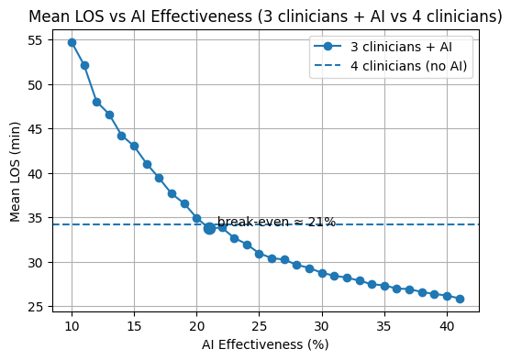
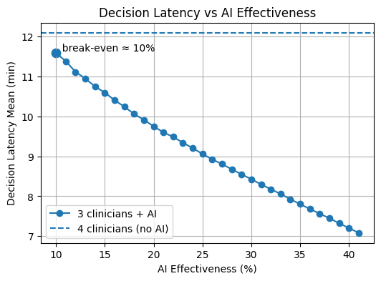
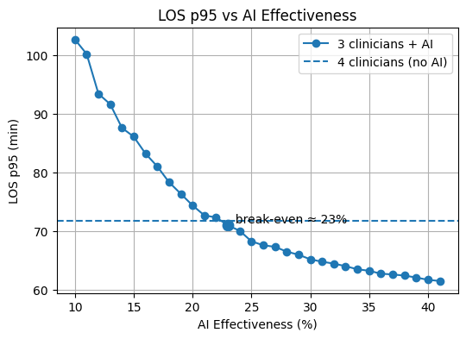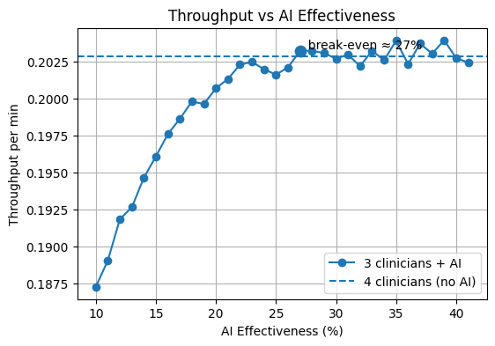
Figure 1: KPI parameters for Low load scenario

Mean Length of Stay
The average length of stay (LOS) reduces as the effectiveness of AI increases. There is a distinct crossover point (21%) where the performance of the three-clinician AI-assisted team equals that of the four-clinician baseline without AI (35 min). If you are below this value, lowering staff increases LOS, whereas, if you are above it, the AI-driven changes in staff prioritization and process coordination compensate completely for the absent clinician. This finding indicates that even if there is no congestion, properly effective AI can reinstate the baseline system level by enhancing consistency throughout the patient care pathway instead of just increasing capacity.

LOS 95th Percentile
The LOS p95 drops consistently with the rise in AI effectiveness, signaling fewer instances of extreme waiting times for patients. The example with four clinicians and no AI shows that the LOS p95 is about 72 minutes, whereas in the scenario with three clinicians and AI support, the LOS p95 is still higher at low levels of AI effectiveness because the rare instances of prioritization errors affect those patients who are already in the worst situation. Still, there is a distinct crossover point at roughly 23% AI effectiveness where the performance of three clinicians with AI equals that of four clinicians without AI. After that, AI not only makes up for one less clinician but also further cuts down the tail delays by making prioritization more stable and keeping the worst process deviations under control. This work demonstrates that even in times of low demand, AI mainly enhances reliability and tail performance rather than the average flow.
* LOS p95 is the value below which 95% of patients are discharged.

Throughput
Throughput rises bit by bit with AI effectiveness and at around 27% AI effectiveness hits the baseline level of four clinicians. Reduced staff below that junction point results in a restriction of the completion rates even with AI support; however, beyond the break-even point, the throughput stays at the baseline level and just varies slightly. This is the expected situation as when the load is low, the system is limited by demand rather than capacity. It is the rate of patient arrivals that limits throughput, not the decision speed or the number of clinicians available. Therefore, AI is unable to significantly increase the number of patients treated once the baseline performance has been achieved. Instead, AI mainly eliminates internal delays without generating extra demand.
From a management point of view, being able to produce the same level of throughput as at baseline with one less clinician on staff can have a few direct economic consequences. If the hospital's income depends on how many patients are treated, being able to provide the same level of throughput as the baseline means that the AI-assisted scenario will not have any revenue loss. And at the same time, cutting staff by one clinician reduces the costs of running the business. Therefore, under conditions of low demand, AI does not really work as a revenue-enhancing tool but more like a cost-efficiency facilitator which enables the hospital to keep up the output while at the same time lowering the labor ​‍​‌‍​‍‌​‍​‌‍​‍‌expenses.

Robustness and Consistency
Following​‍​‌‍​‍‌​‍​‌‍​‍‌ this, Table 3 is presented to serve as an instrument of validation of the analysis reliability. By showing mean values along with standard deviations from 1,000 Monte Carlo replications, the table essentially reveals that the performance patterns taken from the figures are consistent and not random results.
A relatively small and smoothly changing standard deviation level through different levels of AI effectiveness suggests that system operation is generally unaffected by the randomness in arrivals and service dynamics. Notably, a lack of sudden spikes in variance around break-even points serves as evidence that the observed intersections are not the result of rare and unstable simulation outcomes.
Collectively, the table statistically supports that the analysis is done on a well-behaved process.

Table 3: Mean and Standard Deviation of Key Performance Indicators (Monte Carlo Robustness Analysis)
AI Effectiveness (%) | Mean LOS (min) | LOS Std (min) | Mean Throughput (patients/min) | Throughput Std
0 | 34.2 | 8.09 | 0.2029 | 0.0175
10 | 54.74 | 30.25 | 0.1873 | 0.0162
12 | 48.03 | 26.06 | 0.1918 | 0.0155
14 | 43.01 | 21.37 | 0.1961 | 0.015
16 | 39.4 | 17.25 | 0.1986 | 0.0153
18 | 36.56 | 14.85 | 0.1996 | 0.0156
20 | 33.73 | 9.41 | 0.2013 | 0.0162
22 | 32.68 | 8.65 | 0.2025 | 0.0165
24 | 30.94 | 6.05 | 0.2016 | 0.0171
26 | 30.23 | 4.59 | 0.2032 | 0.0173
28 | 29.29 | 4.17 | 0.2031 | 0.017
30 | 28.42 | 2.74 | 0.203 | 0.0171
32 | 27.87 | 2.47 | 0.2033 | 0.0172
34 | 27.33 | 2.24 | 0.2039 | 0.0174
36 | 26.91 | 2.26 | 0.2037 | 0.0179
38 | 26.37 | 2.06 | 0.204 | 0.0174
40 | 25.87 | 1.96 | 0.2024 | 0.0173

7.5 Results – High Load Scenario
This section reports the simulation results under high-demand conditions, where patients arrive on average every 3.3 minutes. Each configuration was evaluated using 1,000 Monte Carlo replications, ensuring statistical robustness of the reported indicators.
Two organizational regimes are compared:
- Baseline (Classic): 4 clinicians, no AI support
- AI-assisted: 3 clinicians supported by an AI assistant with effectiveness levels ranging from 10% to 40% (step = 1%)
The comparison focuses on four key performance indicators (KPIs):
- Decision latency
- Mean Length of Stay (LOS)
- LOS at the 95th percentile (LOS p95)
- Throughput.

Decision latency
In a situation where demand is high, the AI-supported setup with three clinicians at first substantially underperforms the four-clinician baseline because the combination of reduced staff and low AI effectiveness is not enough to handle the increased patient arrival rate. During this stage, decision queues build up very fast and system behavior is dominated by congestion, which causes decision latency to be on the rise.
As the effectiveness of AI steadily rises, the AI assistant helps speed up clinical decision-making increasingly and keeps the accumulation of pending cases to minimum thus enabling the system to gradually get out of the congested state. The progress continues until a distinct break-even point is attained at around 15% of AI effectiveness when the AI-assisted system equals the decision latency of the four-clinician baseline. From a managerial point of view, this milestone defines the lowest AI functionality that would still make it possible to downsize the staff without negatively affecting the performance of the operation.
On the contrary, when the system load is light, such a drop in performance due to congestion is not seen, thereby confirming that the real benefit of AI is made possible only when demand is high enough to put pressure on the capacity and reveal its limitations.

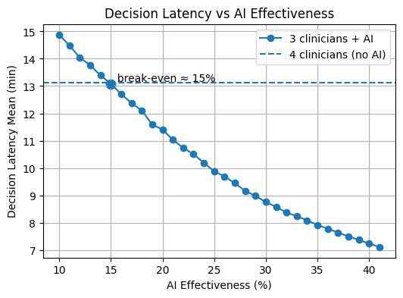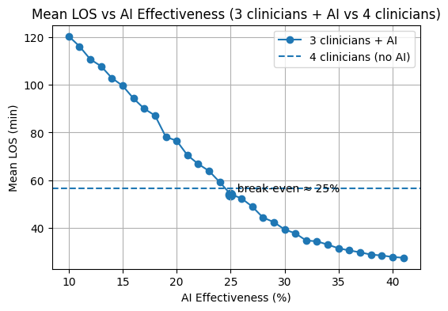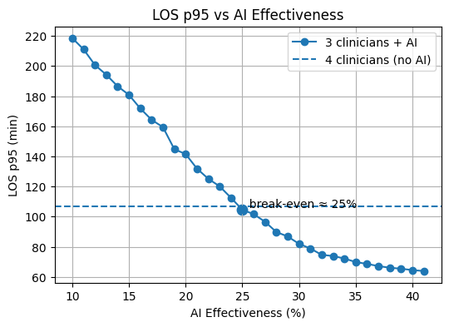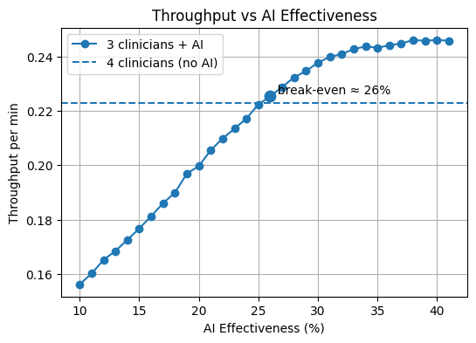
Figure 2: KPI parameters for high load scenario
Mean Length of Stay
Initially, the Mean Length of Stay (LOS) in the three-clinician AI-assisted setup is excessive, which is a direct indication of the deep congestion and thus, the patients spending more time waiting at every stage of their care. Low AI effectiveness combined with one less staff negates the benefits and amplifies the effects of bottlenecks at various stages which then, due to the compounded nature of delays, translates to an enormous increase in LOS (120 min) in comparison with the four-clinician baseline (60 min). With the elevation of AI effectiveness, LOS keeps on declining since decision support implementation is great enough to reflect improvements not only in the quality of choices but also in the sequencing of tasks, treatment, and coordination resulting in a systematic relief of congestion throughout the system.
A distinct break-even point is visible at about 25% AI effectiveness below which the AI-assisted set-up has a negative performance and above which it matches the baseline performance. Subsequently, AI is capable of not just replacing the missing clinician but improving the overall efficiency of the patient flow to an extent that the average length of stay is decreased (40 minutes for 30%). From a managerial point of view, this statement is an indication that under heavy load, AI can lead to the operating regime changing from one dominated by congestion to a balanced one thus allowing the reduction of staffing while maintaining the level of service quality.

LOS 95th Percentile
Initially, LOS p95 is extremely high in the three-clinician AI-assisted setup, implying that patients in the worst situations experience considerable delays when staff levels are cut but AI effectiveness is low. In this situation, the combined effects of congestion and occasionally poor prioritization result in the exacerbation of tail outcomes thus the fraction of patients which, relative to the four-clinician baseline, have experienced an excessively long stay is inconsequently small (220 min). As AI effectiveness goes up, LOS p95 undergoes a drastic fall and this is the indicator of the fact that not only prioritization has been stabilized but also less extreme delays have become increasingly infrequent.
Approximately 25% AI effectiveness is the stage where the break-even point is clearly marked, and the AI-assisted set-up totally equals the baseline tail performance (107 min). At this point and beyond, AI noticeably ups the game of the system from the standpoint of reliability by drastically reducing the chances of occurrence of worse-case situations. From a managerial perspective, this demonstrates the fact that under heavy load, AI's function is pivotal in limiting risk and thus, at the same time, protecting the level of service while the latter being only a minor function of ​‍​‌‍​‍‌​‍​‌‍​‍‌AI.

Throughput
Throughput in the three-clinician AI-assisted configuration increases steadily with AI effectiveness. At low effectiveness levels (around 10%), throughput is approximately 0.155 patients per minute, significantly below the four-clinician baseline of about 0.22 patients per minute, reflecting a clear capacity shortfall. As AI effectiveness improves, throughput rises almost linearly, indicating that AI progressively alleviates congestion and enables faster patient processing.
A clear break-even point is reached at approximately 26% AI effectiveness, where the AI-assisted configuration matches the baseline throughput. Beyond this threshold, throughput continues to increase modestly, stabilizing around 0.24–0.245 patients per minute. From a managerial perspective, this demonstrates that under high load, AI not only compensates for reduced staffing but can also unlock additional productive capacity, enabling both cost efficiency and revenue expansion once a sufficient effectiveness level is achieved.

Robustness and Consistency
As in the low-load scenario, the reported results under high demand are statistically robust. The consistency of mean values and the smooth behavior of standard deviations across AI effectiveness levels confirm that the observed trends are systematic and not driven by stochastic fluctuations. This indicates that the simulation operates in a stable regime and that the performance improvements observed under high load are reliable and reproducible.

Table 4: Mean and Standard Deviation of Key Performance Indicators (Monte Carlo Robustness Analysis)
AI Effectiveness (%) | Mean LOS (min) | LOS Std (min) | Mean Throughput (patients/min) | Throughput Std
0 | 56.53 | 32.45 | 0.2229 | 0.0224
10 | 120.29 | 46.36 | 0.1563 | 0.0251
12 | 110.62 | 44.91 | 0.1652 | 0.0258
14 | 99.54 | 44.63 | 0.1768 | 0.0269
16 | 89.95 | 44.13 | 0.1861 | 0.0278
18 | 78.18 | 41.08 | 0.197 | 0.0264
20 | 70.51 | 39.79 | 0.2055 | 0.0265
22 | 63.92 | 38.31 | 0.2134 | 0.0257
24 | 54.15 | 32.07 | 0.2224 | 0.0219
26 | 49.03 | 28.55 | 0.2288 | 0.0212
28 | 42.54 | 23.2 | 0.2346 | 0.0192
30 | 37.82 | 18.67 | 0.2398 | 0.0172
32 | 34.48 | 15.01 | 0.2427 | 0.0177
34 | 31.57 | 10.04 | 0.2432 | 0.0177
36 | 29.88 | 8.82 | 0.2447 | 0.0188
38 | 28.57 | 6.16 | 0.2457 | 0.019
40 | 27.61 | 3.67 | 0.2457 | 0.0191

7.6 Sensitivity Analysis
The​‍​‌‍​‍‌​‍​‌‍​‍‌ purpose of this sensitivity analysis is to test how the main findings hold up and remain stable when input levels of patient arrivals are slightly varied. The focus is not on bringing out a new set of performance comparisons, but rather on checking whether the initial conclusions made under the nominal low and high load conditions stay valid when the demand varies within realistic limits. So as not to repeat the same thing, the whole work is done at a representative AI productivity level (25%), which corresponds to the break-even region identified.
The sensitivity analysis, by presenting the averages along with the standard deviations from several Monte Carlo runs, pays attention not only to the main trends but also to the variations. This helps figure out if the system performance deteriorates gradually or shows unstable behavior when there are small changes in demand, which is important for judging the dependability of the staffing and AI-related choices.

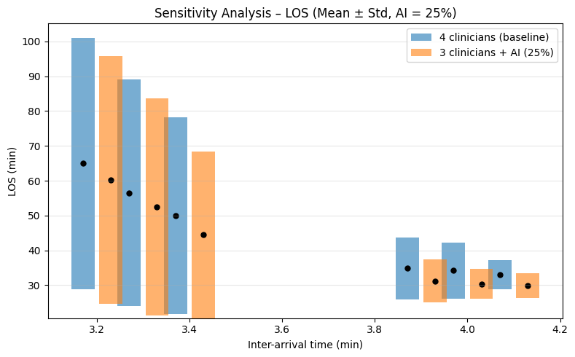
Figure 3: Sensitivity Analysis – LOS

Results - Mean Length of Stay (LOS)
The sensitivity of mean LOS to variations in inter-arrival time is illustrated in Figure 3 for both the baseline configuration (four clinicians) and the AI-assisted setup (three clinicians with AI effectiveness fixed at 25%). Across both high-load (3.2, 3.3, and 3.4 minutes) and low-load (3.9, 4.0, and 4.1 minutes) regimes, LOS varies smoothly with changes in arrival rates. Importantly, the performance gap between the baseline and AI-assisted configurations in terms of LOS remains largely unchanged. In addition, the variability bands of the two configurations mostly overlap, indicating that the impact of AI remains consistent across different demand levels rather than being confined to extreme operating conditions.

Results - Throughput
The corresponding sensitivity results for throughput are reported in Figure 4. As inter-arrival time increases, demand intensity decreases and, as expected, throughput declines accordingly. For both configurations, however, throughput changes gradually and exhibits limited variability. The AI-assisted setup consistently maintains throughput levels comparable to the baseline across the examined range of arrival rates. This confirms that the throughput parity achieved at the nominal operating point persists under moderate demand fluctuations. Consequently, even when arrival rates deviate from their reference values, AI-enabled capacity compensation remains effective and preserves system performance.

Overall Sensitivity Assessment
Overall, the sensitivity analysis confirms that the main findings are robust and internally consistent. Variations in patient arrival rates induce only smooth and predictable changes in both LOS and throughput, without altering the relative performance comparison between the baseline and AI-assisted configurations. From a managerial perspective, this implies that the proposed AI-supported staffing reduction does not rely on finely tuned demand assumptions, but remains valid under realistic uncertainty in patient arrivals.

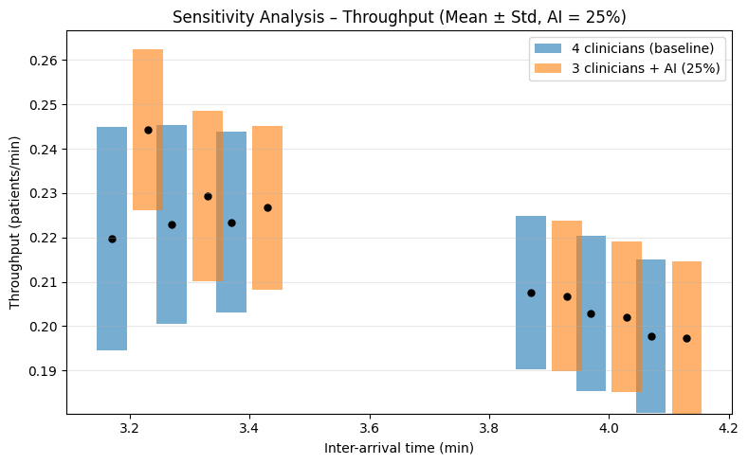
Figure 4: Sensitivity Analysis - Throughput

8. Discussion
This section interprets the simulation results through the lenses of healthcare operations management, systems thinking, and strategic management. Rather than reiterating quantitative findings, the discussion focuses on why AI-assisted decision regimes generate the observed organizational effects and under what conditions these effects translate into sustainable value creation.
8.1 Interpretation via Management and Systems Theory
The results indicate that the primary organizational impact of AI-driven treatment decision tools arises from their ability to reduce decision delays and variability, rather than from increasing capacity or improving clinical accuracy. From a healthcare operations perspective, this finding aligns with established theories identifying unmanaged variability and delayed decision-making as major sources of congestion, inefficiency, and instability in care delivery systems.
By accelerating and stabilizing clinical decision processes, AI-assisted regimes weaken delay–deterioration feedback mechanisms. Faster decisions reduce the likelihood that patients deteriorate while waiting, which in turn lowers admission rates, shortens lengths of stay, and reduces downstream resource congestion. These effects accumulate across the system, resulting in smoother patient flow and preserved throughput under unchanged demand and capacity conditions. Importantly, the observed efficiency gains emerge without increasing utilization intensity, indicating that AI improves coordination efficiency rather than simply accelerating resource consumption.
From a systems thinking perspective, the findings highlight the importance of feedback structures and time delays in shaping organizational outcomes. Consistent with system dynamics theory, local process improvements translate into system-level benefits only when they modify the feedback loops governing congestion and flow. The simulation results suggest that AI-driven decision support functions as a structural intervention, altering the timing and consistency of decisions in ways that stabilize system behavior rather than shifting bottlenecks elsewhere.
Together, these insights reinforce the interpretation of AI-driven treatment decision tools as process innovations whose organizational value derives from stabilizing decision-making and mitigating cascading inefficiencies. This perspective contrasts with dominant narratives that frame AI primarily as a mechanism for improving diagnostic accuracy and underscores the need for evaluation frameworks that explicitly capture dynamic, system-level effects.
8.2 SWOT-Based Strategic Reflection
From a strategic management perspective, the proposed framework and findings can be contextualized using a SWOT-oriented reflection that highlights internal characteristics of the approach and external conditions shaping its applicability.
Strengths
A central strength of this study lies in its systems-oriented evaluation framework, which integrates agent-based modeling with value-based performance metrics. By explicitly linking agent behavior, feedback dynamics, and organizational KPIs, the framework enables evaluation of AI-driven decision tools beyond task-level accuracy or user satisfaction. Emphasizing variability, stability, and distributional outcomes aligns the analysis with core principles of healthcare operations and value-based management. In addition, the framework supports ex ante strategic analysis, allowing managers to explore AI adoption scenarios without disrupting real-world operations.
Weaknesses
As with all simulation-based approaches, the framework relies on abstraction and modeling assumptions. Results depend on the representation of decision rules, agent behavior, and parameter values, and the model cannot capture the full richness of real-world clinical practice or long-term clinical outcomes. Furthermore, the technical complexity of agent-based models may limit transparency for some stakeholders, underscoring the importance of clear communication and visualization when translating results into managerial insights.
Opportunities
Externally, the framework aligns with growing adoption of AI-driven decision tools and increasing emphasis on value-based reimbursement and accountability. The rising interest in digital twins and simulation-based decision support presents opportunities to embed such models into strategic planning, capacity management, and AI governance processes. The approach may also be extended to regional or system-level analyses, informing policy design and investment prioritization.
Threats
Regulatory uncertainty, liability concerns, and resistance to AI adoption related to trust and professional autonomy may constrain implementation in some contexts. There is also a risk that efficiency-oriented metrics could be misinterpreted if decoupled from quality and outcome considerations. To mitigate these risks, the framework explicitly embeds quality-preserving constraints and value-based performance logic, emphasizing that efficiency gains are meaningful only when aligned with patient outcomes and system stability.

Synthesis
Taken together, the discussion demonstrates that the organizational benefits of AI-driven treatment decision tools depend less on technological sophistication than on their ability to reshape decision timing, reduce delay-induced deterioration, and stabilize system dynamics. By integrating systems theory, healthcare operations insights, and value-based management principles, this study provides a strategic lens for understanding when and how AI adoption can contribute to sustainable value creation in healthcare organizations.

9. Managerial Implications
The findings of this study offer several important implications for healthcare managers, clinical leaders, and policymakers responsible for evaluating and governing AI-driven treatment decision tools. Rather than treating AI adoption as a purely technical or clinical decision, the results underscore the need to approach AI as a strategic organizational intervention whose value depends on how it reshapes decision processes, coordination, and system dynamics.
9.1 Using the Framework for Ex-Ante Strategic Evaluation
A key managerial implication of this work is the importance of ex-ante evaluation. Healthcare organizations frequently adopt AI technologies based on evidence of diagnostic accuracy, pilot studies, or vendor claims, without systematically assessing organizational consequences. The proposed simulation-based framework enables managers to evaluate AI-driven decision tools prior to large-scale deployment under realistic demand and capacity conditions.
By experimenting with alternative decision regimes in a virtual environment, managers can anticipate how AI support influences patient flow, congestion, clinician workload, and system stability. This capability is particularly valuable in high-pressure healthcare settings where real-world experimentation would be costly, risky, or ethically constrained. Rather than asking whether an AI system performs well in isolation, managers can assess whether it improves organizational efficiency and value under their specific operational constraints.
9.2 Moving Beyond “Accuracy-Only” Decision Making
The results highlight the limitations of AI evaluation strategies that focus exclusively on predictive accuracy or clinical performance metrics. While accuracy is a necessary condition for safe AI deployment, it is not sufficient to ensure organizational value creation. AI tools that marginally improve accuracy may still fail to deliver efficiency gains—or may even introduce new inefficiencies—if they disrupt workflows, increase variability, or exacerbate congestion.
Managers should therefore complement accuracy-based assessments with organizational performance indicators such as length of stay, throughput, variability, and system stability. Notably, the simulation results indicate that relatively modest reductions in decision latency (approximately 20–25%) can compensate for reduced staffing without degrading organizational performance, highlighting the importance of process-level effects over marginal gains in predictive accuracy. Adopting a value-based evaluation perspective allows decision-makers to distinguish between AI tools that add technical sophistication and those that meaningfully improve outcomes per unit of organizational effort.
9.3 Designing AI Adoption as a Process Innovation
From a strategic management perspective, AI-driven treatment decision tools should be implemented as process innovations, not as stand-alone technologies. The simulation results demonstrate that efficiency gains emerge when AI reduces decision delays and stabilizes coordination, thereby dampening congestion feedback loops. Managers should therefore prioritize integration strategies that align AI support with existing workflows, decision hierarchies, and coordination mechanisms.
This implies investing not only in technology, but also in training, change management, and governance structures that support effective use. AI adoption strategies that neglect organizational context risk triggering policy resistance, whereby well-intentioned interventions fail to produce sustained improvements due to feedback effects and system adaptation. Simulation-based exploration helps managers anticipate such resistance and design more resilient, context-sensitive implementation strategies.

9.4 Supporting Long-Term Value Creation and Organizational Resilience
Finally, the framework provides a foundation for aligning AI adoption with long-term value creation rather than short-term efficiency gains. By emphasizing stability, variability reduction, and quality-preserving constraints, the approach helps managers avoid strategies that optimize local metrics at the expense of system resilience. This is particularly important in healthcare environments exposed to demand surges, workforce shortages, and regulatory constraints.
In practice, managers can use the framework to explore trade-offs between efficiency, quality, and robustness, identify thresholds beyond which performance degrades, and prioritize AI investments that strengthen organizational resilience. By doing so, AI-driven decision tools can be positioned not merely as productivity enhancers, but as strategic assets supporting sustainable, value-based healthcare delivery.

10. Limitations and Future Research
While this study provides a structured and theoretically grounded framework for evaluating the organizational impact of AI-driven treatment decision tools, several limitations must be acknowledged. Recognizing these limitations is essential for appropriate interpretation of the results and for guiding future research directions.
10.1 Model Calibration and Data Availability
A primary limitation of the proposed agent-based model concerns calibration. As with many simulation-based studies of complex organizational systems, the model relies on stylized representations of patient behavior, clinician decision-making, and system constraints. Although parameter choices are informed by existing literature and validated through pattern-oriented techniques, the absence of direct calibration using institution-specific operational data limits the precision of quantitative estimates.
Future research could address this limitation by integrating empirical data from healthcare organizations deploying AI-driven decision tools, enabling more accurate calibration of decision latency distributions, deterioration dynamics, and workload thresholds. Such calibration would enhance external validity while preserving the model’s role as a comparative and exploratory evaluation tool rather than a predictive instrument.
10.2 Scope of Clinical Outcomes
The focus of this study is explicitly on organizational efficiency and value-based performance rather than long-term clinical outcomes such as mortality, disease progression, or quality-adjusted life years. While outcome proxies such as deterioration and escalation rates are incorporated to preserve quality constraints, the model does not capture downstream health outcomes beyond the simulated care cycle.
Future extensions could incorporate longer-term patient trajectories, enabling analysis of cumulative outcomes across repeated care episodes, particularly in chronic disease management contexts. Such extensions would allow a richer assessment of value creation but would require additional clinical data and modeling complexity, reinforcing the need to balance realism with interpretability.
10.3 Abstraction and Representation of Organizational Complexity
Healthcare organizations are inherently complex adaptive systems with institutional, cultural, and regulatory dimensions that extend beyond operational processes. While the agent-based approach captures key feedback loops, delays, and interaction patterns, it necessarily abstracts from factors such as organizational culture, informal coordination practices, and political dynamics.
This limitation is consistent with systems thinking perspectives that emphasize the role of simplified models in learning and policy exploration rather than precise prediction. Future research could enhance realism by incorporating adaptive learning behaviors, role differentiation among clinicians, or organizational norms that influence decision-making and technology use.
10.4 Extending the Model to Cost Dynamics and Long-Term Value
An important avenue for future research involves extending the current agent-based model to explicitly represent cost dynamics. While this study evaluates efficiency through time-based and flow-based metrics, organizational value in healthcare is ultimately expressed through the interaction between outcomes and costs over time.
Future model extensions could incorporate multiple cost components, including:
- Per-patient treatment costs, linked to length of stay, treatment intensity, and escalation events;
- Resource utilization costs, such as bed occupancy, clinician time, and diagnostic or therapeutic equipment usage;
- Maintenance and depreciation costs of medical equipment, which are sensitive to utilization intensity and congestion-driven overuse;
- Delay-induced cost accumulation, reflecting how prolonged waiting and deterioration increase downstream resource consumption.
By linking these cost structures to existing agent behaviors—such as deterioration, admission decisions, and resource occupancy—the model could quantify how AI-driven reductions in decision latency and congestion translate into long-term cost savings rather than short-term efficiency gains alone. This would enable direct estimation of cost per patient, cost per treated episode, and cumulative organizational costs under alternative AI adoption scenarios.
10.5 Long-Term and Dynamic Cost Scenarios
Building on cost integration, future research could explore longitudinal simulation horizons to examine how AI-driven decision support influences organizational costs over extended periods. Such scenarios could capture cumulative effects such as:
- Reduced wear and maintenance of equipment due to smoother utilization patterns;
- Lower marginal costs per patient as congestion-driven inefficiencies are dampened;
- Cost escalation under sustained overload when AI effectiveness remains below critical thresholds;
- Trade-offs between upfront AI investment costs and long-term operational savings.
These extensions would align the simulation framework more closely with value-based healthcare principles by explicitly connecting efficiency improvements to sustainable financial performance.
10.6 Opportunities for Hybrid Modeling Approaches
Another promising direction lies in integrating agent-based modeling with system dynamics (SD) approaches. While ABM excels at representing heterogeneous agents and localized interactions, SD provides powerful tools for modeling aggregate accumulations such as costs, budgets, and capital investments over time.
Hybrid ABM–SD models could link micro-level decision processes to macro-level financial dynamics, such as capacity investment, equipment renewal cycles, workforce planning, and reimbursement mechanisms. Such hybrid approaches would be particularly valuable for studying policy resistance, budget constraints, and unintended consequences of large-scale AI adoption.

10.7 Broader Applications and Generalization
Finally, while the present study focuses on AI-driven treatment decision tools within healthcare organizations, the proposed framework has broader applicability. Similar modeling approaches could be used to evaluate digital decision support in other complex service systems, including emergency response, logistics, and public administration.
Future research could explore these extensions to assess the generalizability of the framework across domains characterized by high variability, capacity constraints, and long-term cost-performance trade-offs.

11. Conclusion
This study addressed a critical gap in the evaluation of AI-driven treatment decision tools by shifting the analytical focus from task-level performance to organizational efficiency and value creation. While AI technologies in healthcare are frequently assessed using accuracy, usability, or user satisfaction metrics, such evaluations offer limited insight into how these tools reshape system-wide performance within complex healthcare organizations.
By conceptualizing healthcare delivery as a complex adaptive system and modeling AI-driven decision support as an organizational process innovation, this research demonstrated how changes in decision timing, coordination, and variability give rise to emergent improvements in efficiency and stability. Using an agent-based modeling framework, the study showed that AI-assisted decision support can stabilize patient flow and reduce congestion-driven inefficiencies under unchanged demand and capacity conditions.
A central contribution of this work lies in identifying decision delays and variability as key mechanisms through which organizational inefficiencies arise and persist. The simulation results indicate that AI-driven decision support creates value primarily by reducing these delays, dampening feedback loops that amplify congestion, and improving the predictability of care processes. By explicitly linking agent-level behavior to organizational KPIs and value-based performance, the proposed framework provides a systematic basis for evaluating AI interventions at the system level.
From a managerial perspective, the study offers a structured approach for ex-ante evaluation of AI adoption strategies. The framework enables healthcare leaders to explore trade-offs, anticipate unintended consequences, and align AI investments with long-term organizational objectives under realistic operational constraints.
As AI adoption in healthcare accelerates, organizationally grounded evaluation frameworks such as the one proposed here will be essential to ensure that technological progress translates into sustainable value creation rather than unintended inefficiency.

References
Porter, M. E. (2010). What is value in health care? New England Journal of Medicine, 363(26), 2477–2481.
Core reference for value-based healthcare and outcome/cost framing.

Topol, E. J. (2019). High-performance medicine: The convergence of human and artificial intelligence. Nature Medicine, 25(1), 44–56.
AI as a response to system pressure; decision support framing.

Braithwaite, J., Churruca, K., Ellis, L. A., et al. (2019). Complexity science in healthcare: Aspirations, approaches, applications and accomplishments. BMJ Quality & Safety, 28(8), 701–706.
Healthcare as a complex adaptive system.

Sterman, J. D. (2000). Business Dynamics: Systems Thinking and Modeling for a Complex World. McGraw-Hill.
System dynamics, feedback loops, delays, policy resistance.

Litvak, E., & Long, M. C. (2000). Cost and quality under managed care: Irreconcilable differences? American Journal of Managed Care, 6(3), 305–312.
Variability as a root cause of inefficiency; cost–quality thresholds.

Esmaeilzadeh, P. (2020). Use of AI-based tools for healthcare purposes: A survey study from consumers’ perspectives. BMC Medical Informatics and Decision Making, 20, Article 170.
Adoption, trust, sociotechnical factors.

Fahim, M., et al. (2025). Artificial intelligence applications in healthcare: A comprehensive review. Frontiers in Computer Science, 5, 1187299.
Overview of AI-driven treatment decision tools.

Bennett, C. C., & Hauser, K. (2013). Artificial intelligence framework for simulating clinical decision-making: A Markov decision process approach. Artificial Intelligence in Medicine, 57(1), 9–19.
Sequential decision modeling; delay and risk accumulation.

Jones, A., et al. (2020). An agent-based model of healthcare system capacity and patient flow. Journal of Artificial Societies and Social Simulation, 23(4), 3.
ABM for flow, congestion, and capacity (NC MInD–style work).

Heath, B., Hill, R., & Ciarallo, F. (2009). A survey of agent-based modeling practices (January 1998 to July 2008). Journal of Artificial Societies and Social Simulation, 12(4), 9.
ABM design principles and validation.

Khairat, S., Marc, D., Crosby, W., & Al Sanousi, A. (2018). Reasons for physicians not adopting clinical decision support systems. Studies in Health Technology and Informatics, 251, 111–114.
Human factors and workflow resistance.

A Systematic Review of User-Centred Evaluation of Clinical Decision Support Systems. (2023). Journal of Medical Systems.
UX-focused evaluation gap; lack of organizational KPIs.

Epstein, J. M. (2006). Generative Social Science: Studies in Agent-Based Computational Modeling. Princeton University Press.
Emergence and micro–macro linkage.

Homer, J. B., & Hirsch, G. B. (2006). System dynamics modeling for public health. American Journal of Public Health, 96(3), 452–458.
SD foundations relevant to hybrid ABM–SD.

